**Assignment B: Test Driven Development**

**Presented to Professor Robert Sabourin**

**For the course ECSE 428: Software Engineering Practice**

**On March 4th, 2018**

**Presented by:**

**HUANG, Yin Jun – 260743592**

**LEI, Jun Yu – 260738036**

**Table of Contents**

Test 1: validInputTest 3

Test x: validUpperLowerFromPostalCode 6

Test x: validUpperLowerToPostalCode 6

Test x: validUpperLowerPostType 6

Test x: noArgsTest 6

Test x: lessThanSevenArgs 7

Test x: moreThanSevenArgs 7

Test x: invalidFromPostalCode 7

Test x: invalidToPostalCode 7

Test x: invalidPostType 7

Test x: nonExistentFromPostalCode 7

Test x: nonExistentToPostalCode 8

Test x: nonMatchingPostalCodes 8

Test x: invalidDimensions 8

Test x: invalidWeight 8

Test x: lessOrEqualToZeroDimensions 8

Test x: lessOrEqualToZeroWeight 8

Test x: overMaxDimensions 8

Test x: overMaxWeight 9

# Test 1: validInputTest

Purpose: Verify postal rate calculator logic works for a valid set of user inputs.

Setup: P0B1L0 H4A1H3 xpress 15 15 15 15

Expected Result: 26.85

Failing Screen Shot

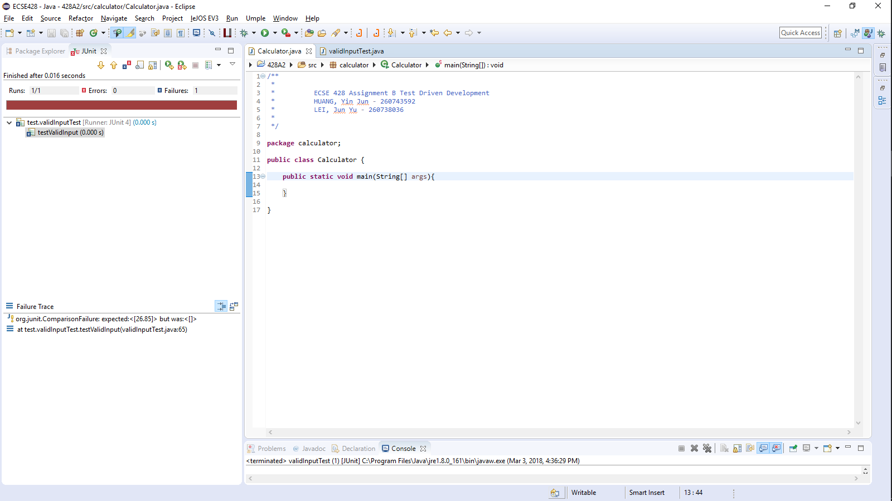

Succeeding Screen Shot

calculator.java:

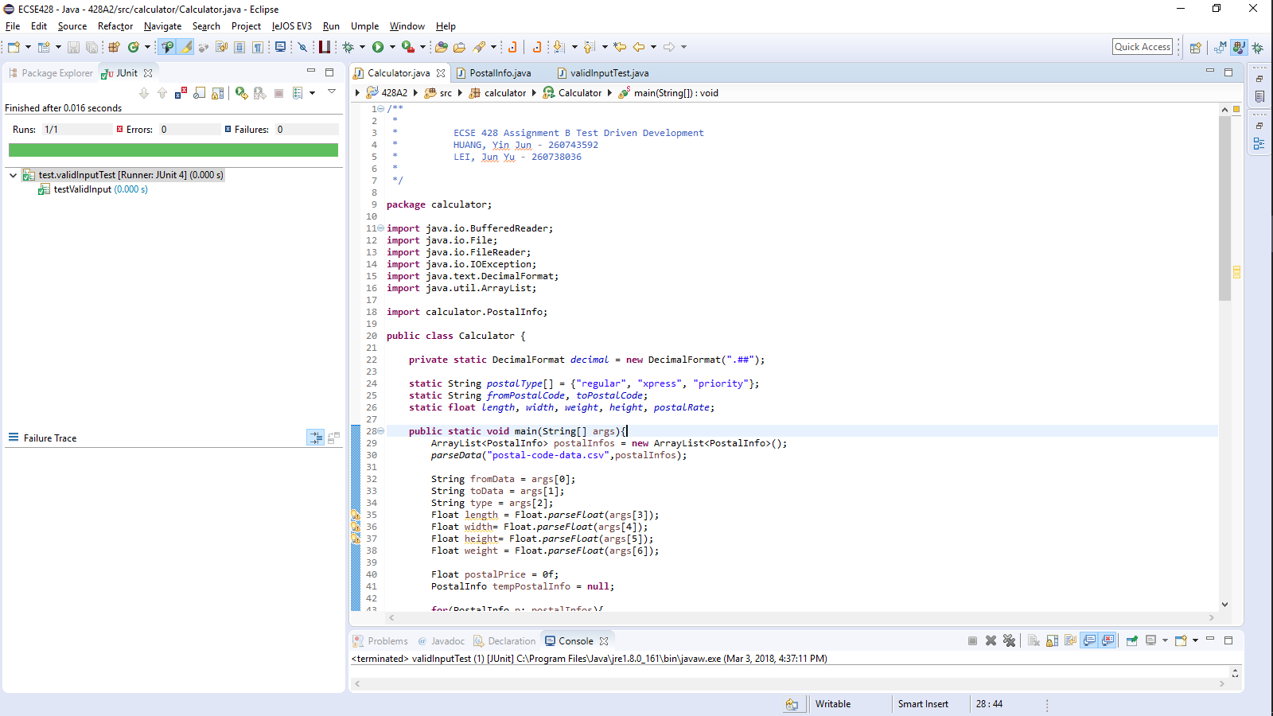

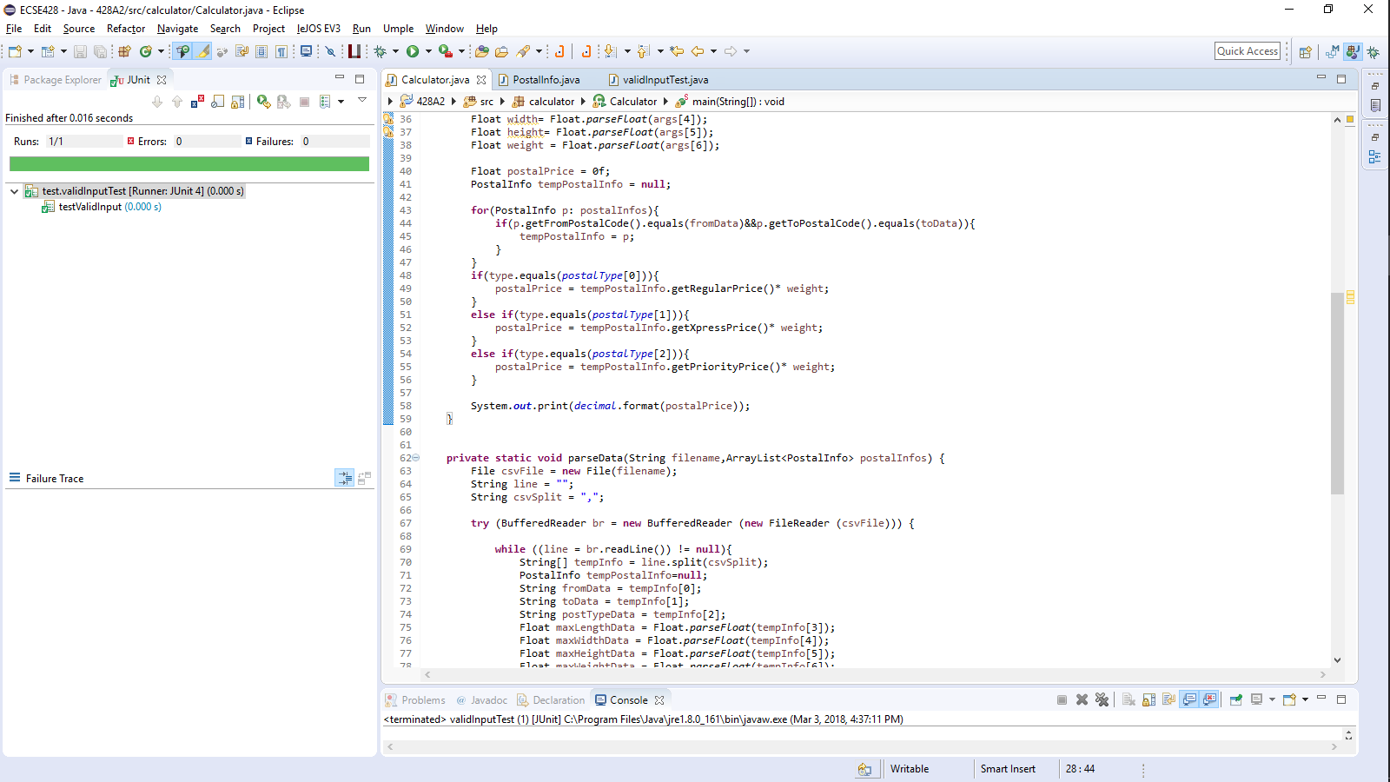

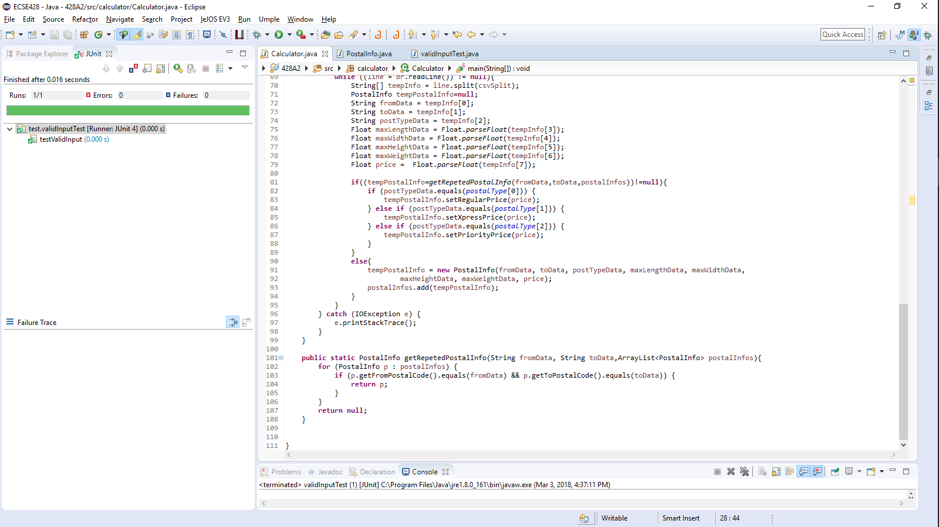

PostalInfo.java

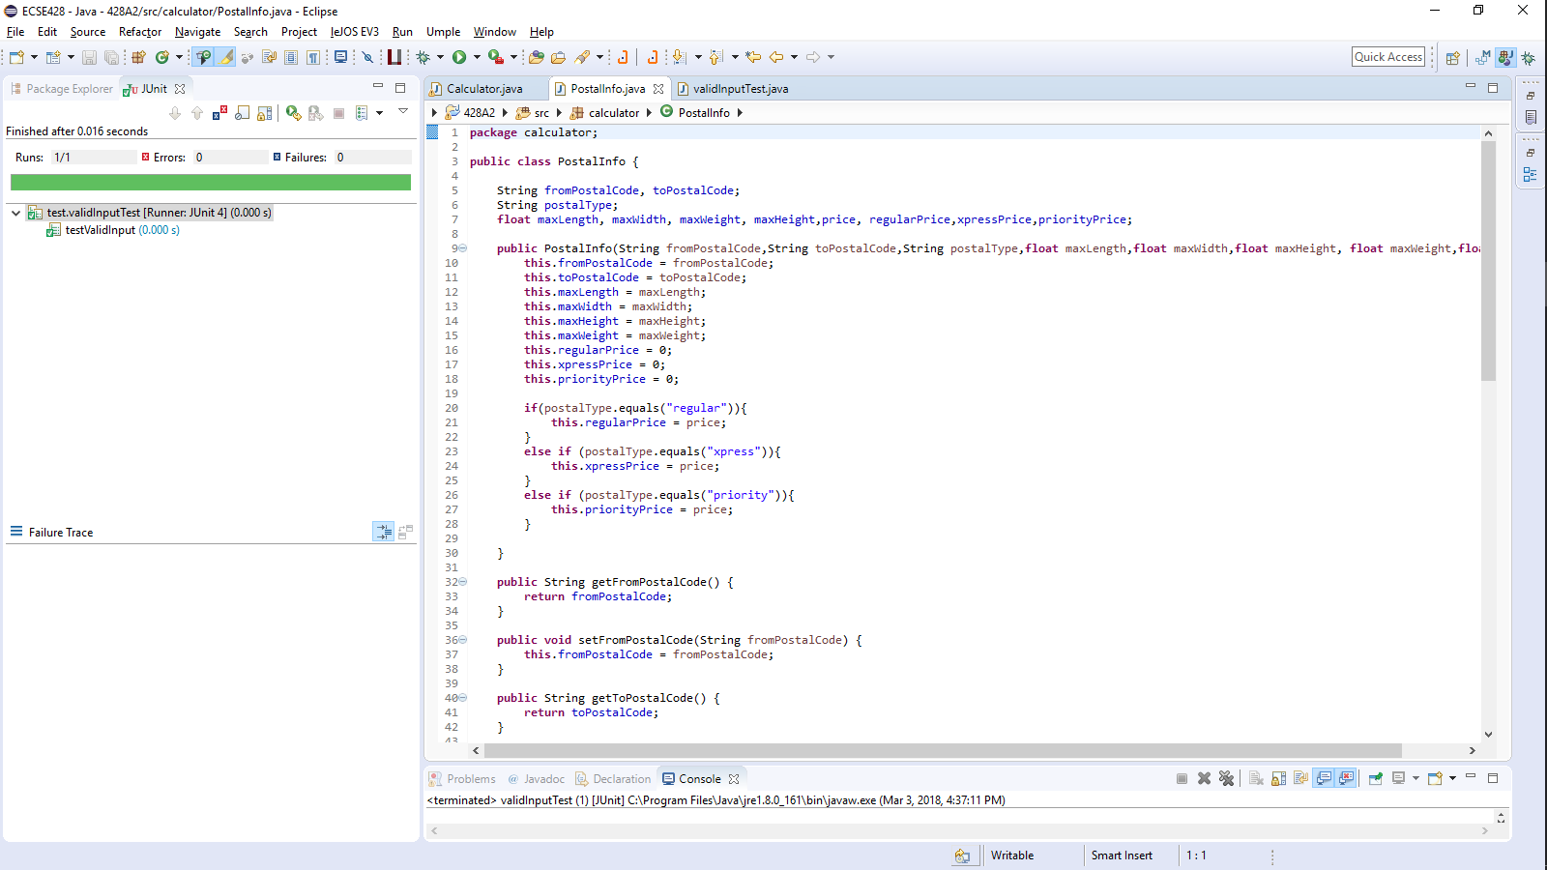

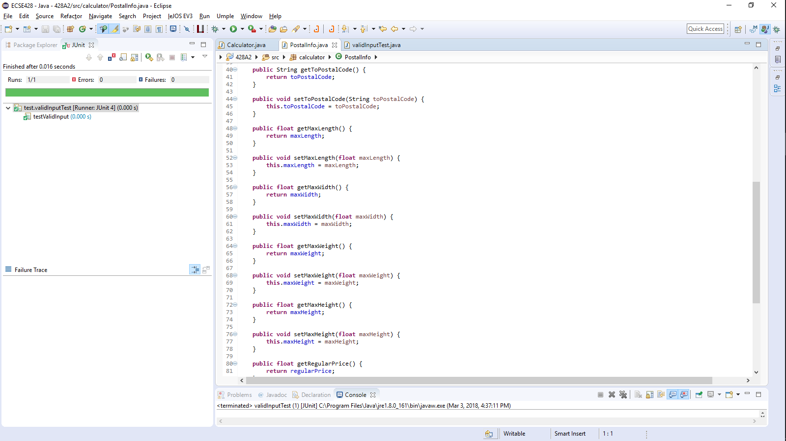

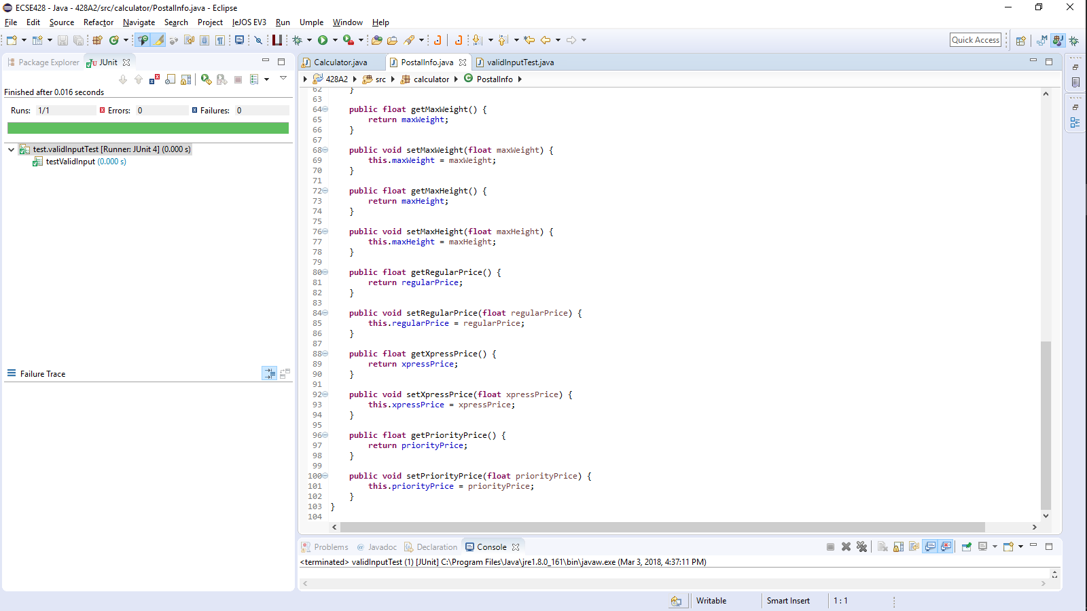

# Test x: validUpperLowerFromPostalCode

Description:

Setup:

Expected Result:

Failing Screen Shot

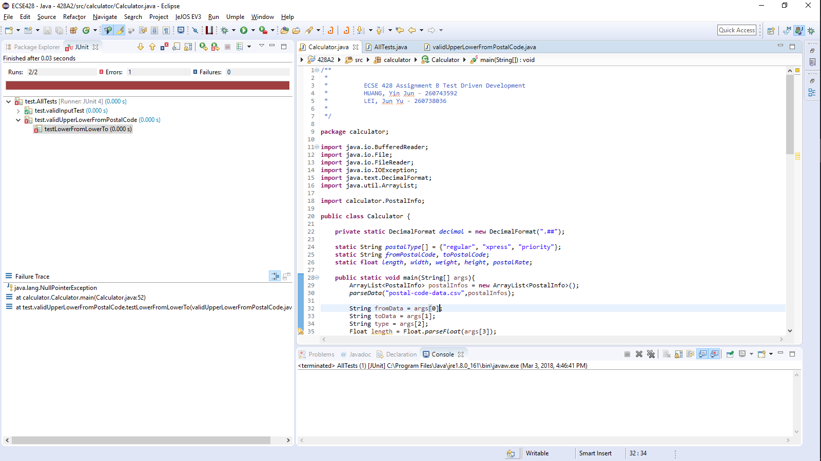

Succeeding Screen Shot

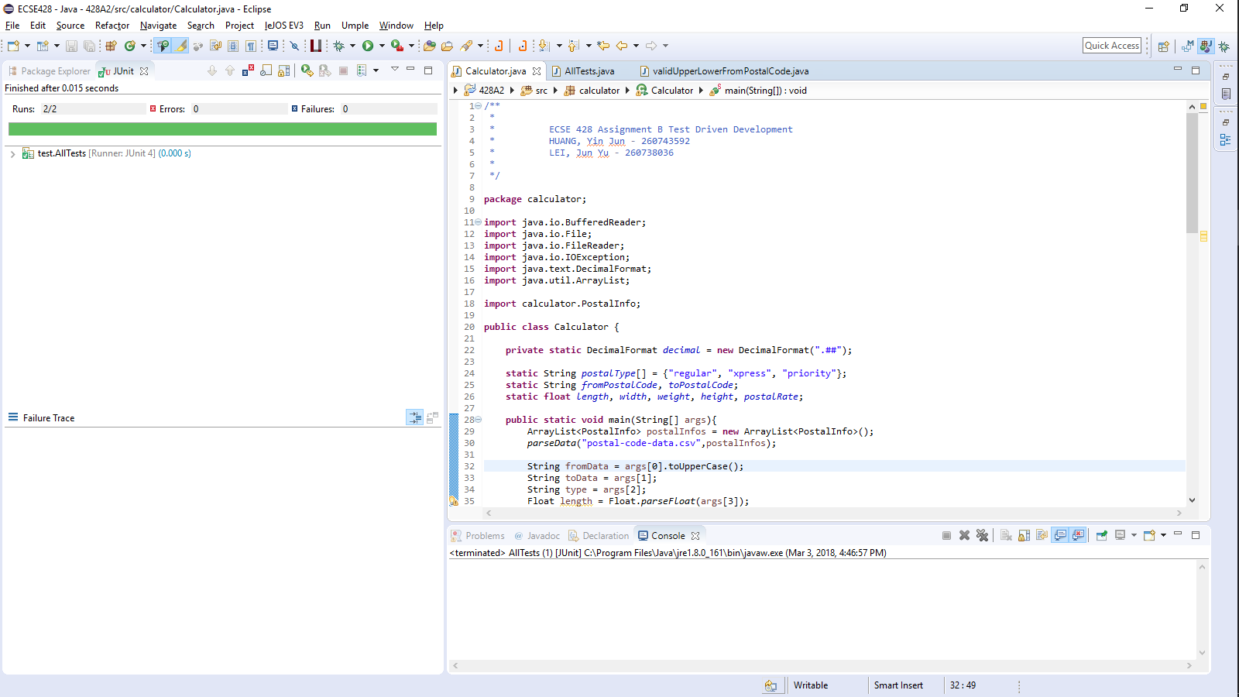

# Test x: validUpperLowerToPostalCode

Description:

Setup:

Expected Result:

Failing Screen Shot

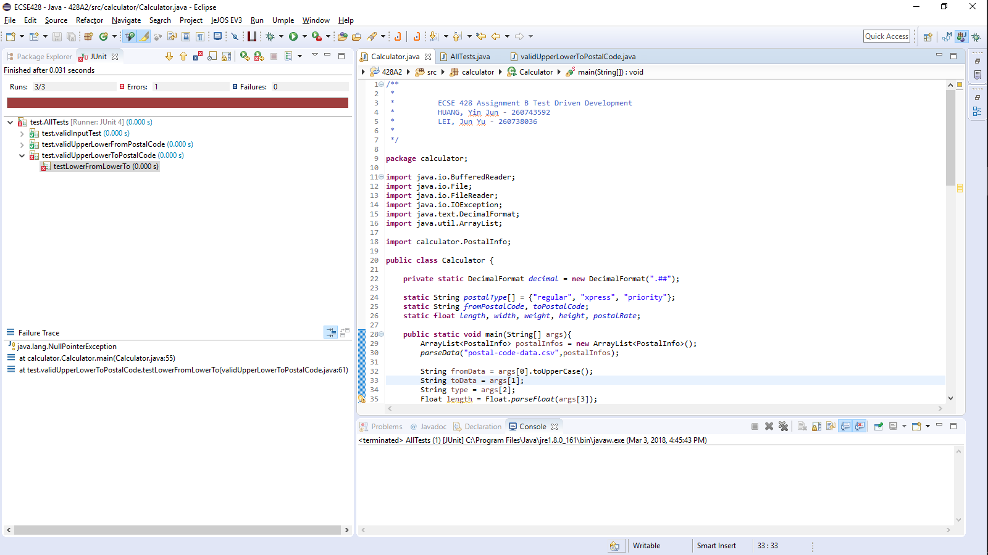

Succeeding Screen Shot

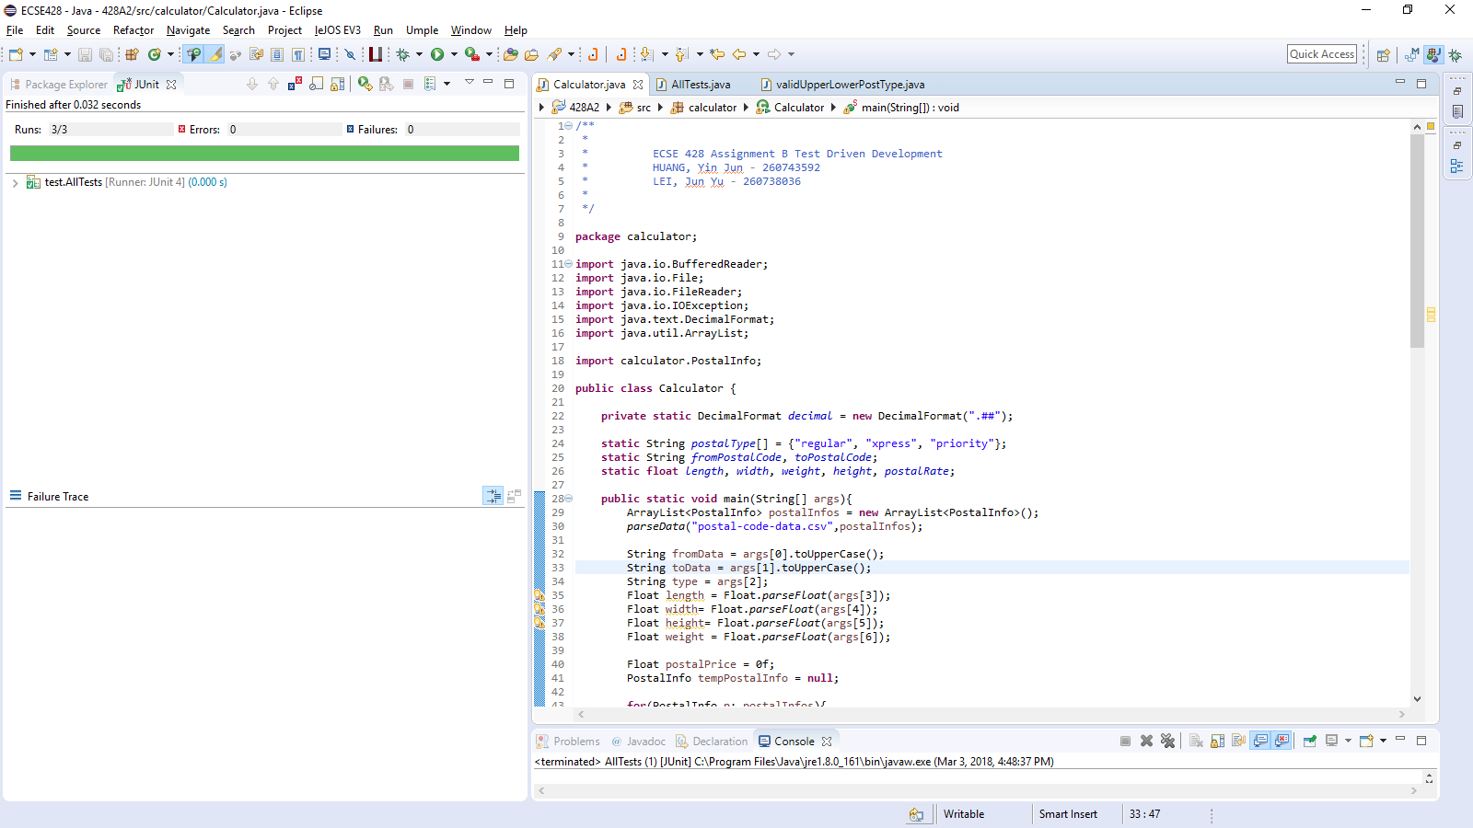

# Test x: validUpperLowerPostType

Description:

Setup:

Expected Result:

Failing Screen Shot

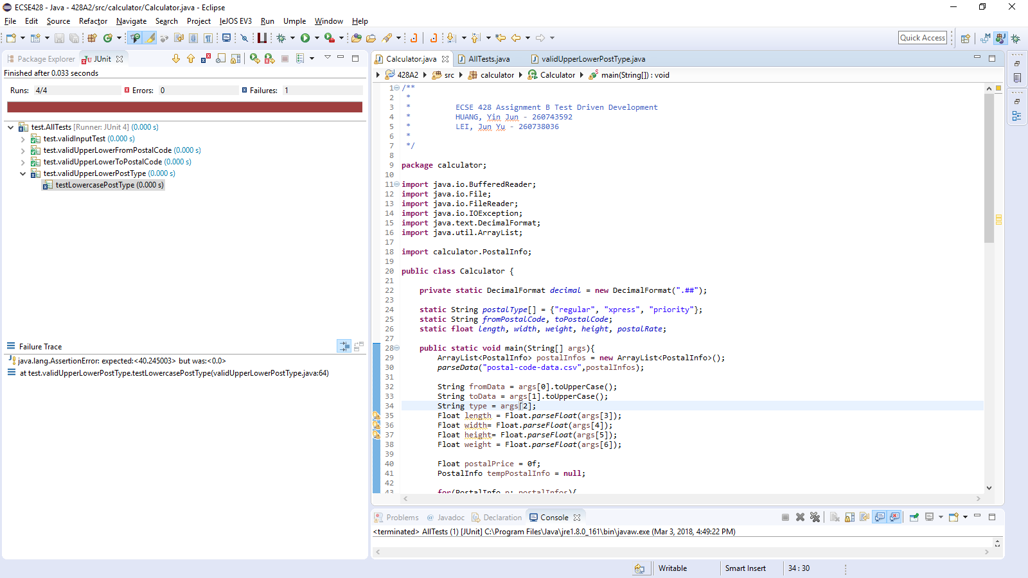

Succeeding Screen Shot

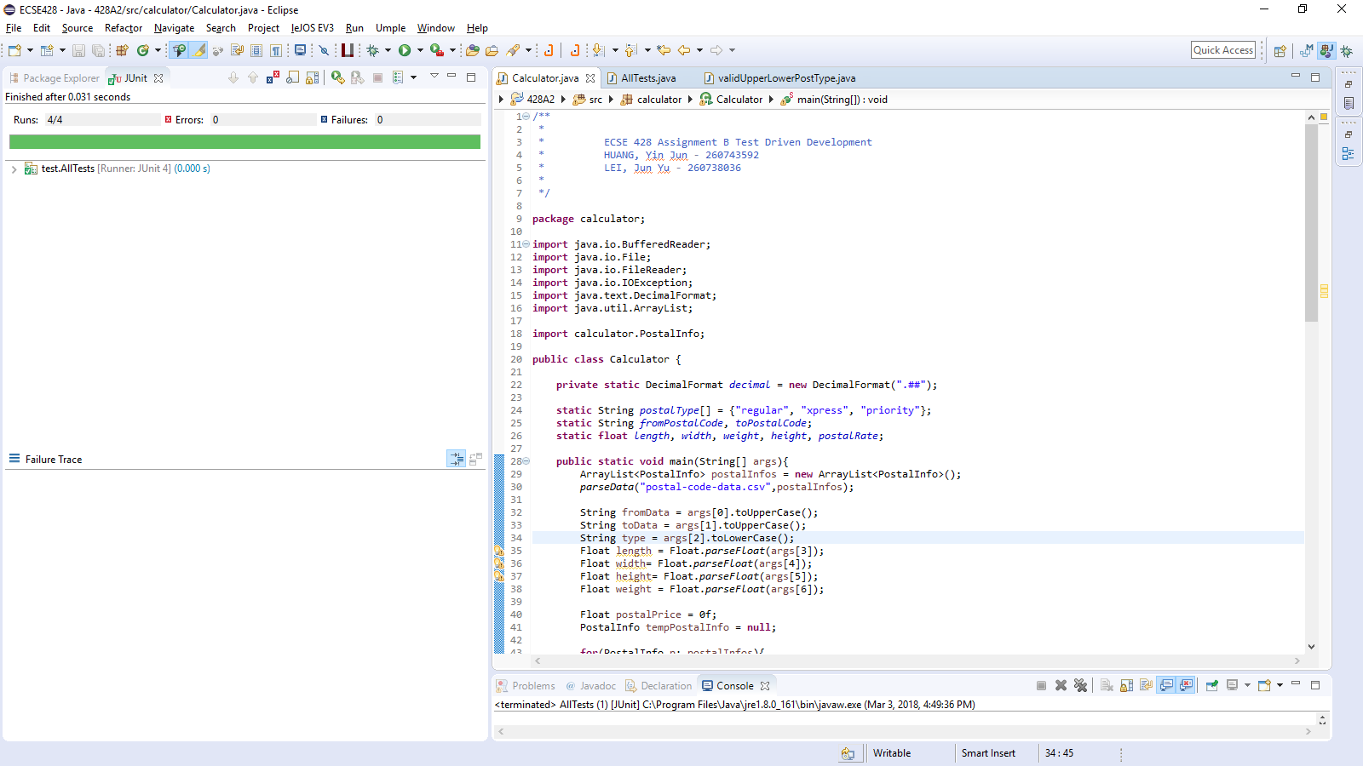

# Test x: noArgsTest

Description:

Setup: Calculator

Expected Result: “Usage: Calculator fromPostalCode toPostalCode postType length width height weight”

Failing Screen Shot

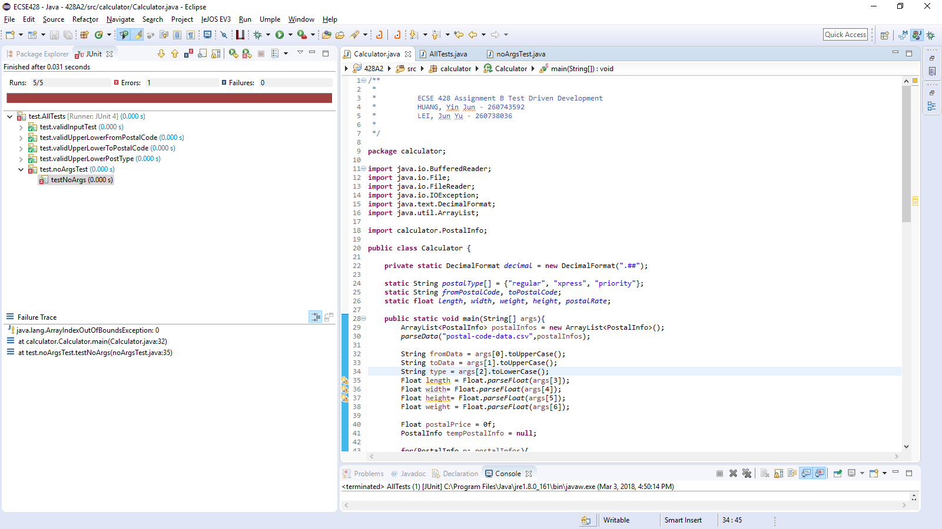

Succeeding Screen Shot

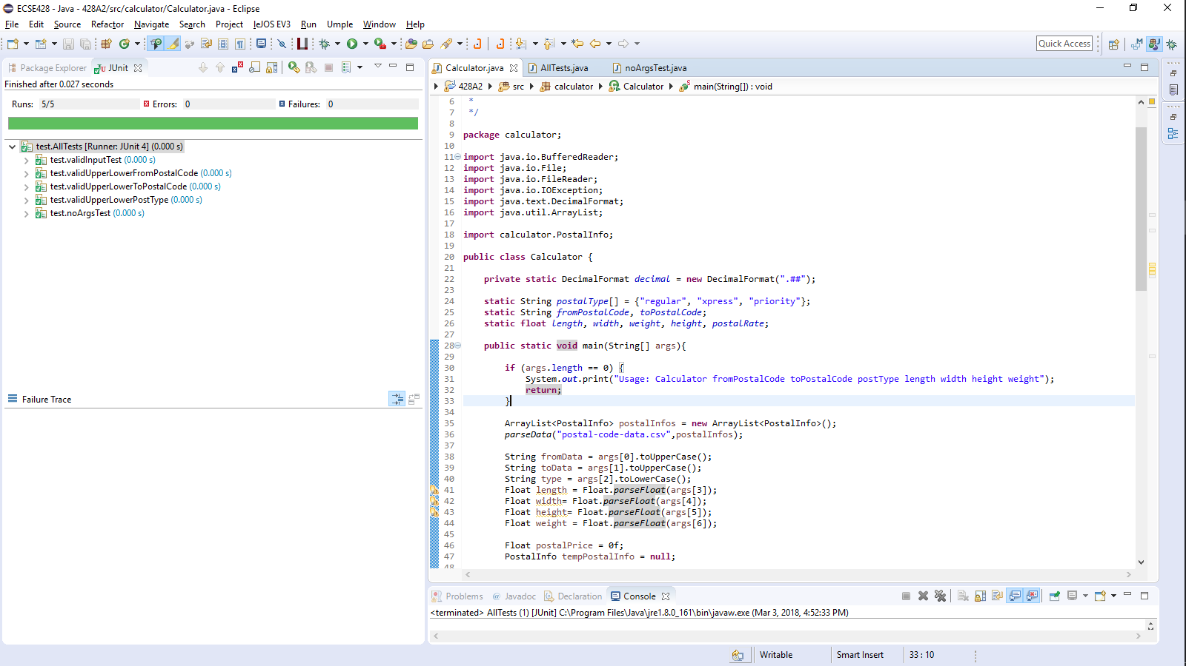

# Test x: lessThanSevenArgs

Description:

Setup:

Expected Result:

Failing Screen Shot

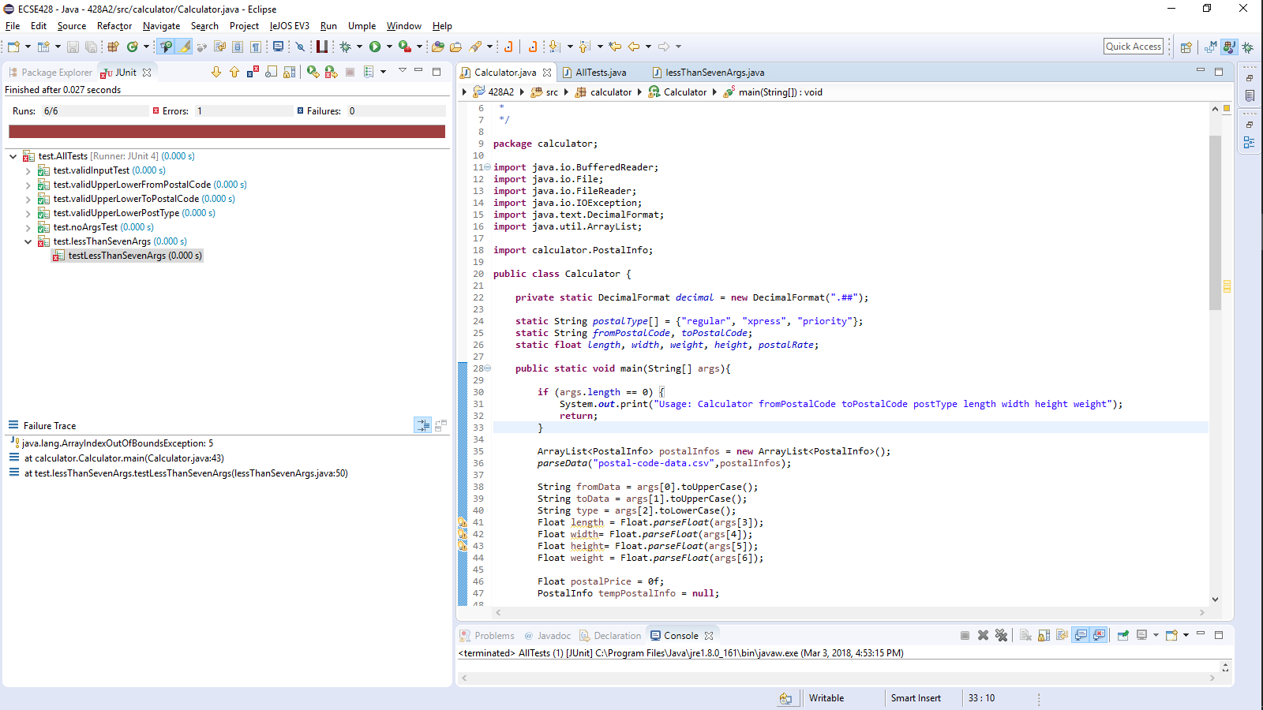

Succeeding Screen Shot

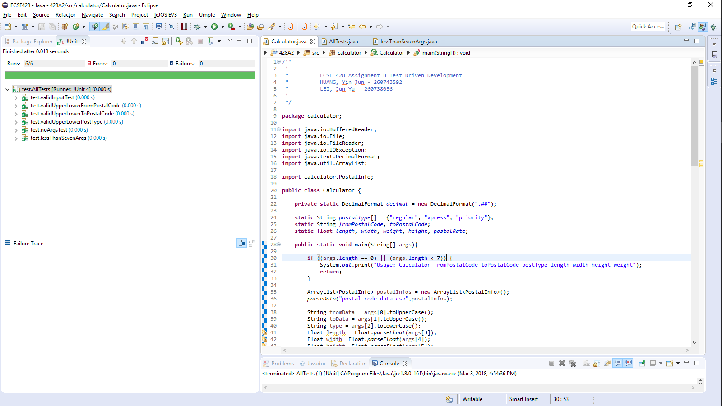

# Test x: moreThanSevenArgs

Description:

Setup:

Expected Result:

Failing Screen Shot

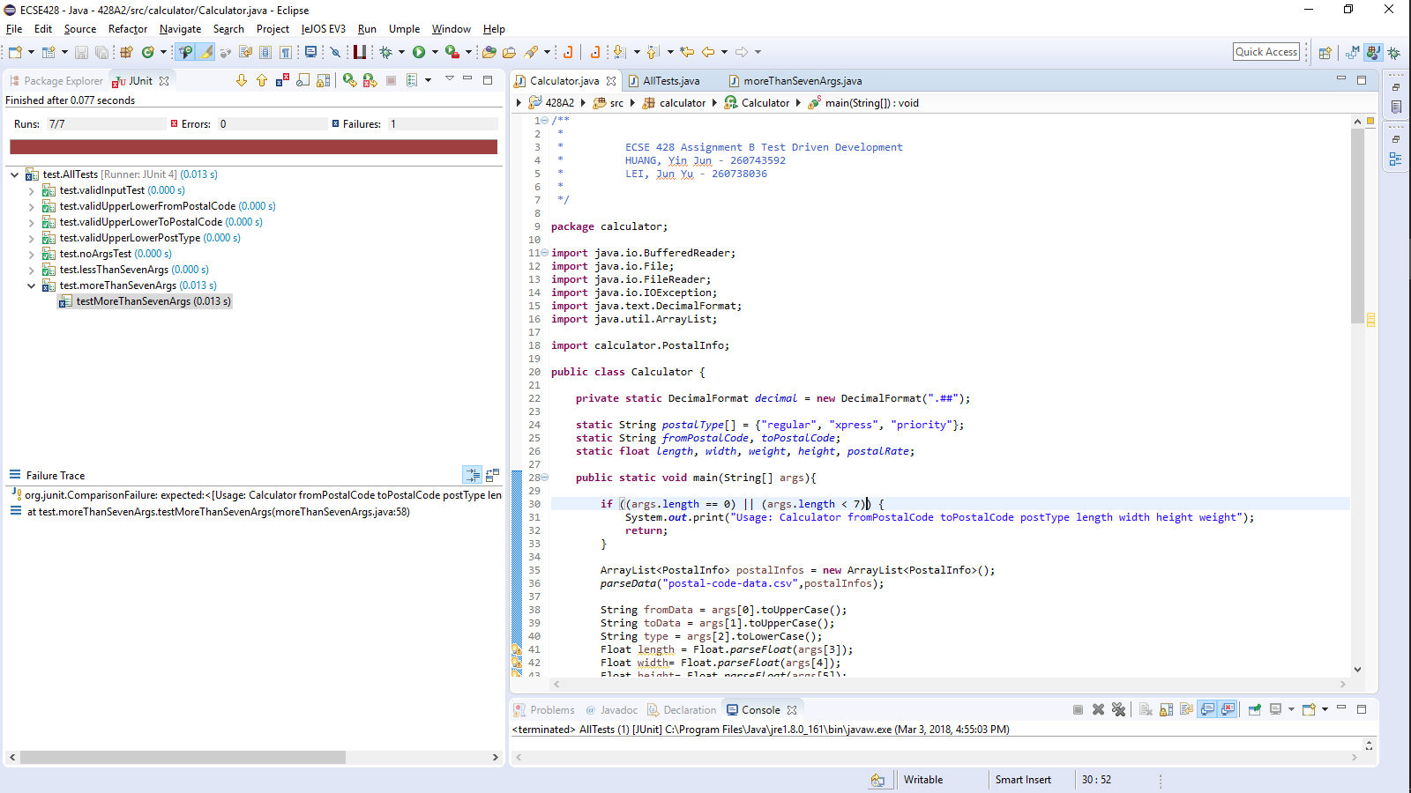

Succeeding Screen Shot

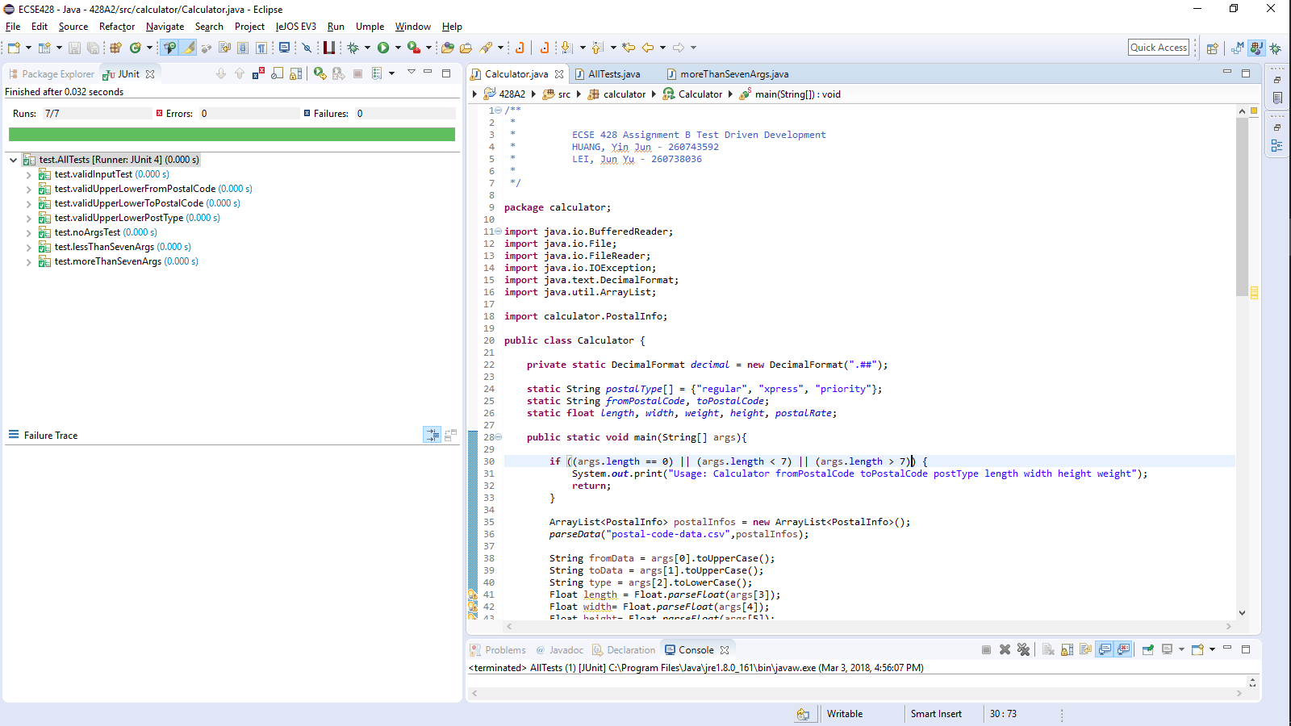

# Test x: invalidFromPostalCode

Description:

Setup:

Expected Result:

Failing Screen Shot

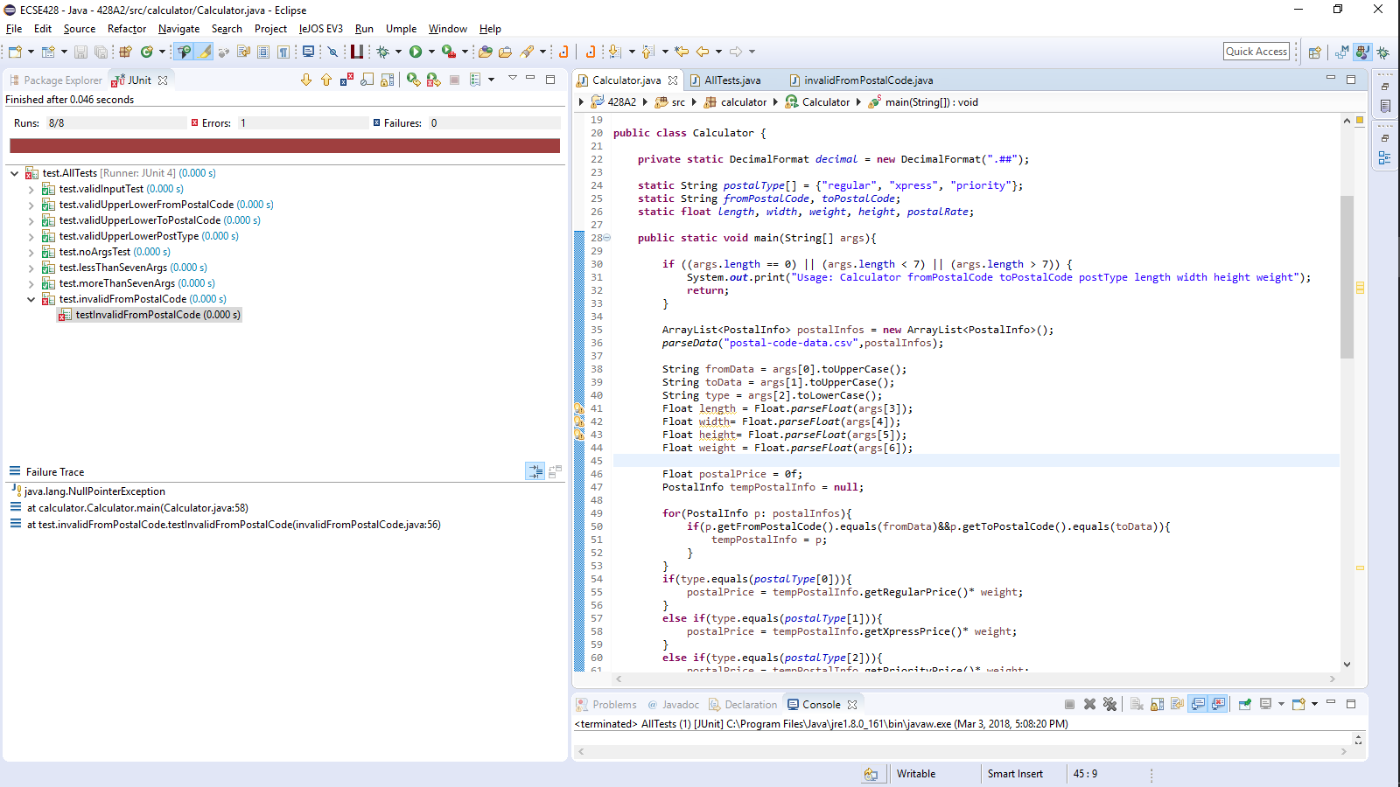

Succeeding Screen Shot

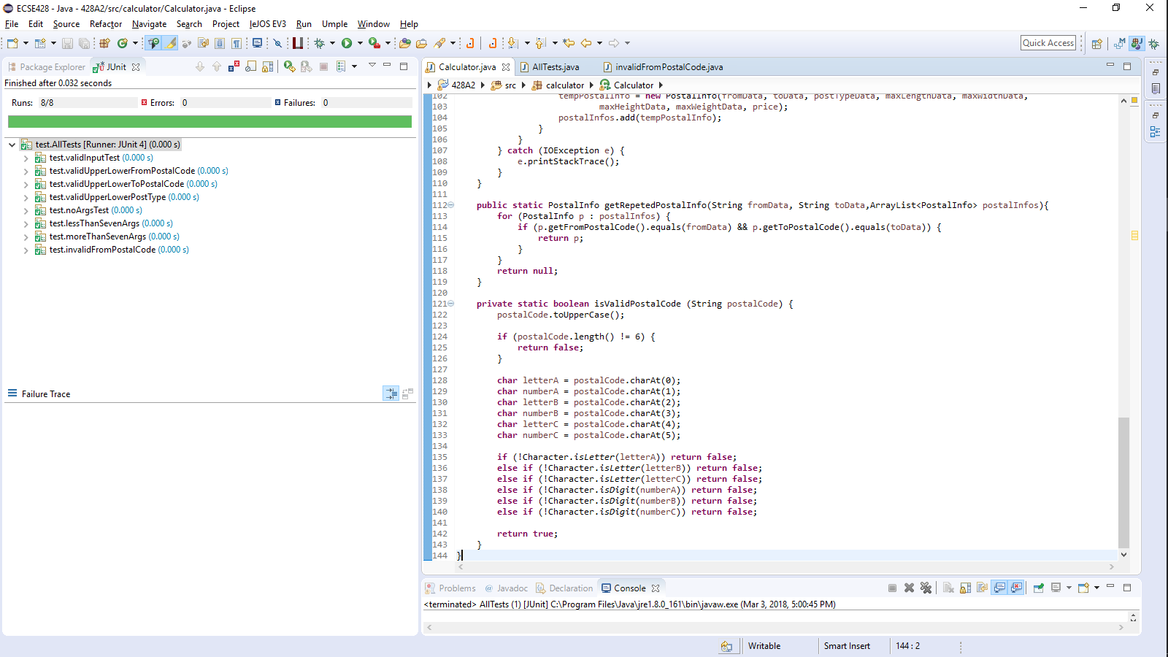

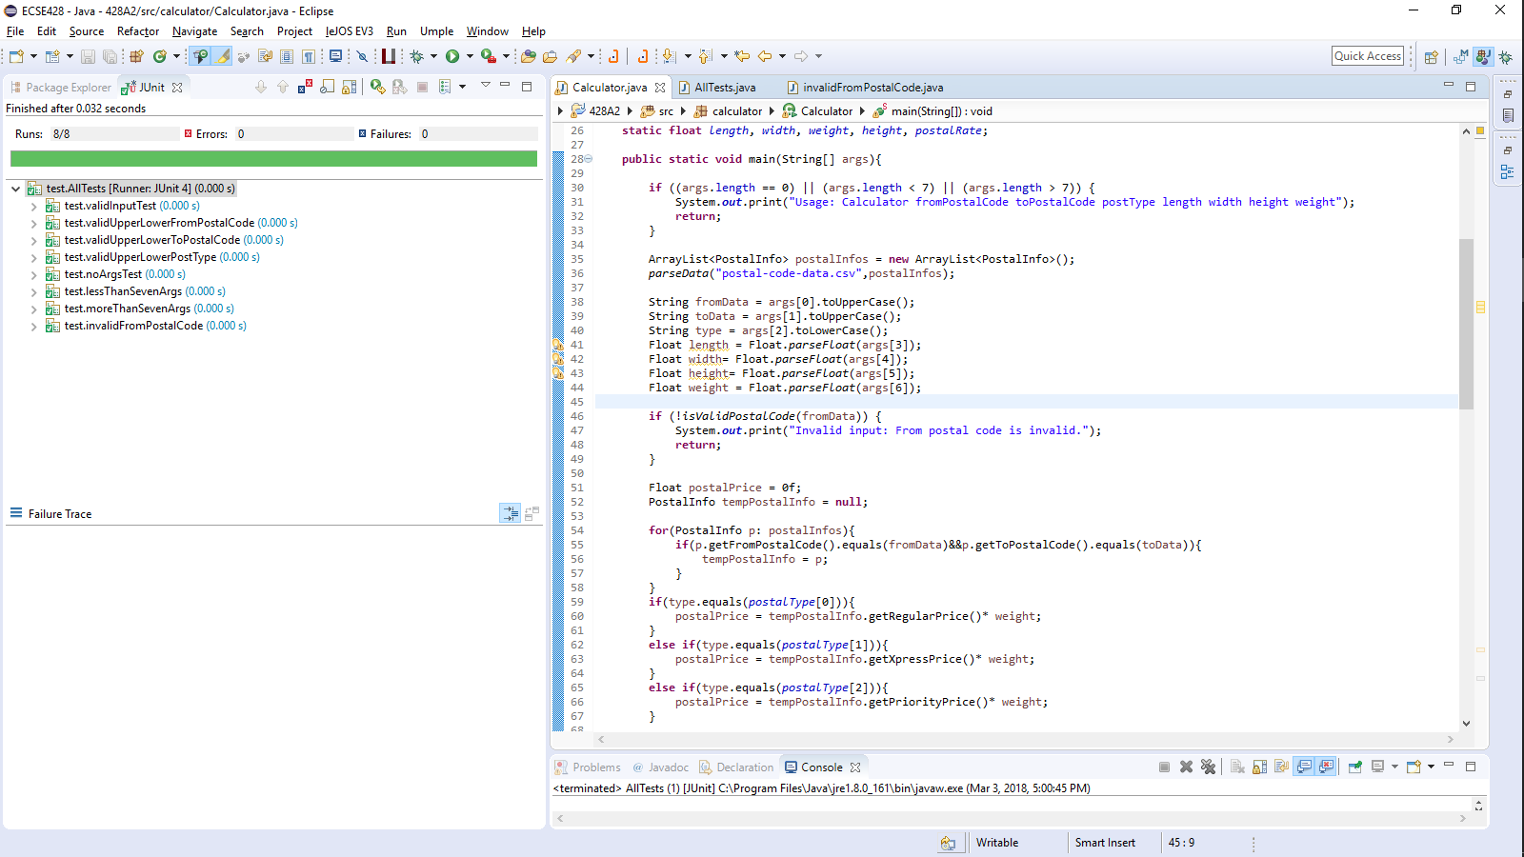

# Test x: invalidToPostalCode

Description:

Setup:

Expected Result:

Failing Screen Shot

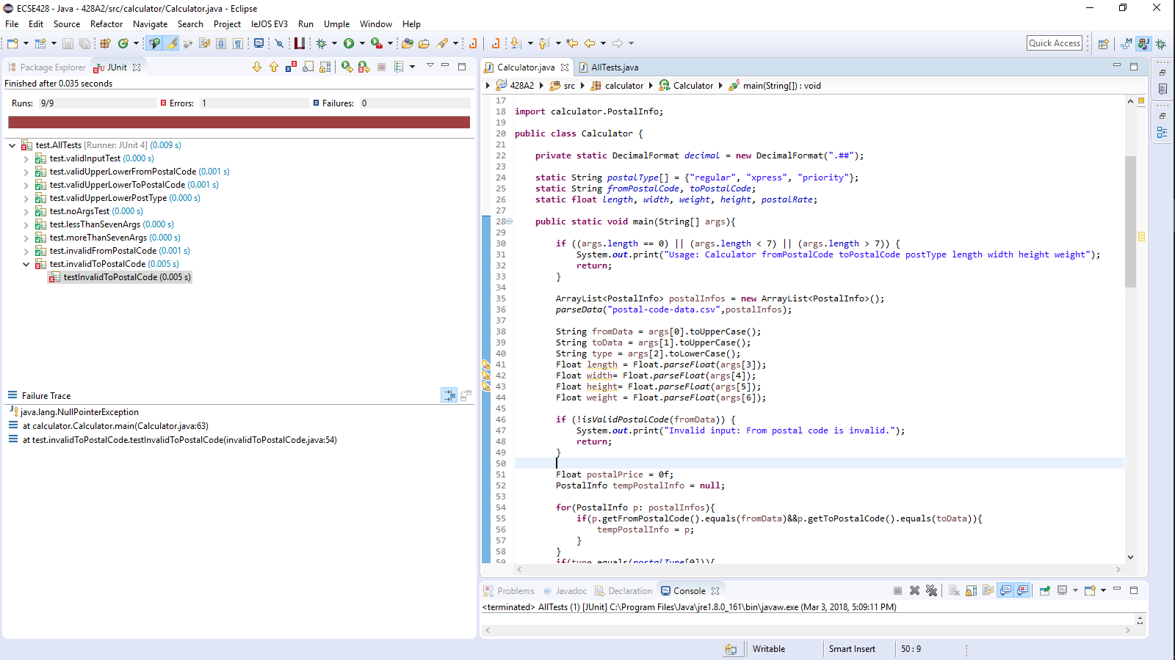

Succeeding Screen Shot

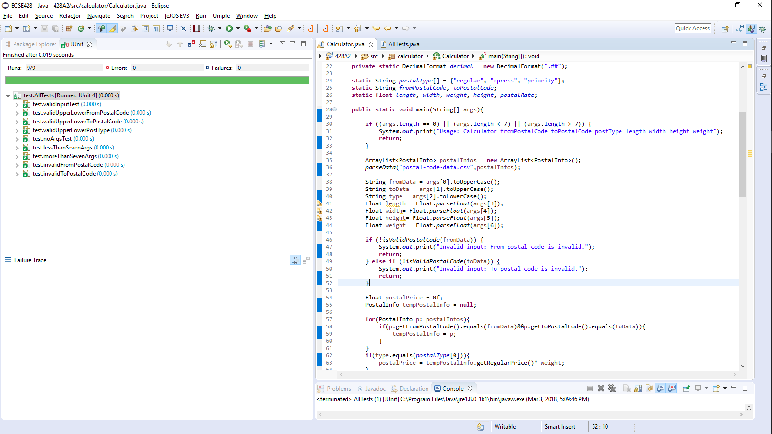

# Test x: invalidPostType

Description:

Setup:

Expected Result:

Failing Screen Shot

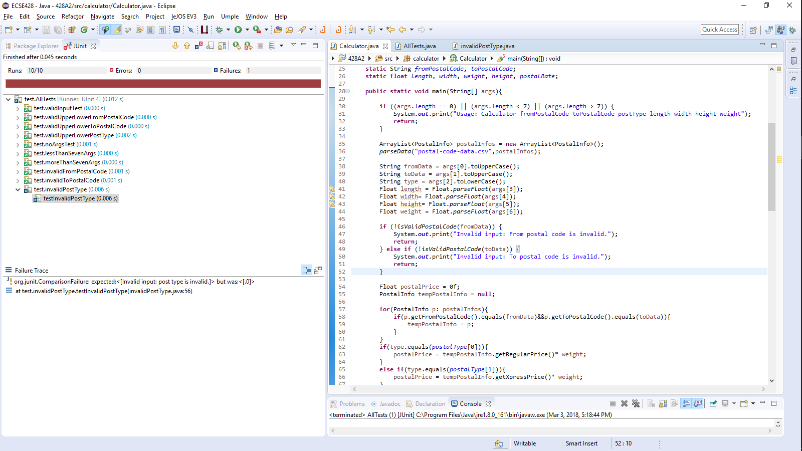

Succeeding Screen Shot

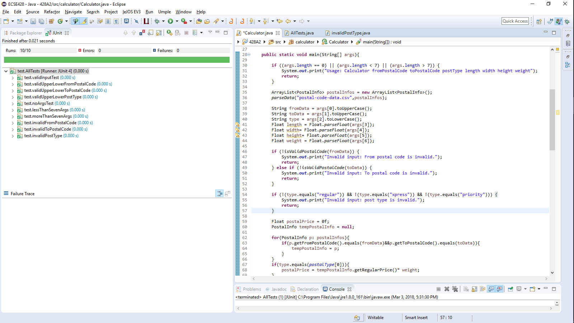

# Test x: nonExistentFromPostalCode

Description:

Setup:

Expected Result:

Failing Screen Shot

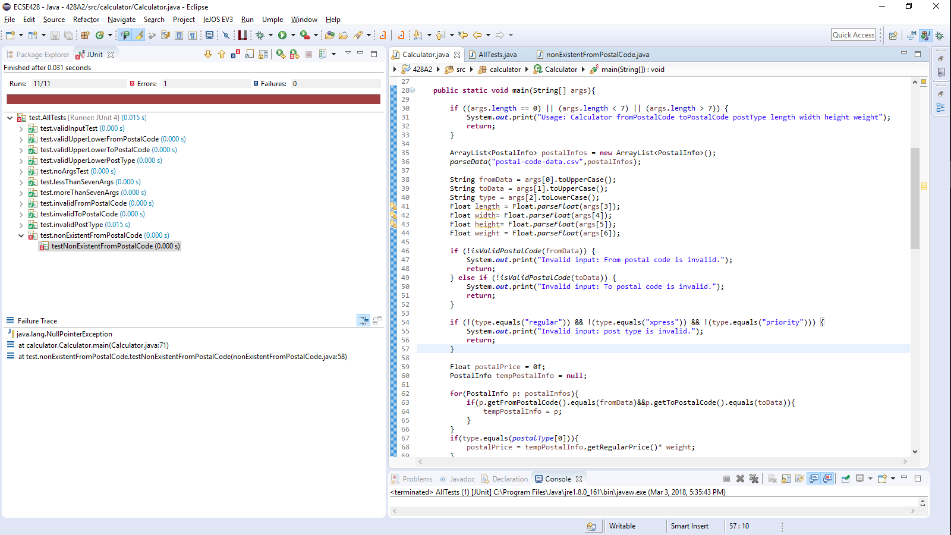

Succeeding Screen Shot

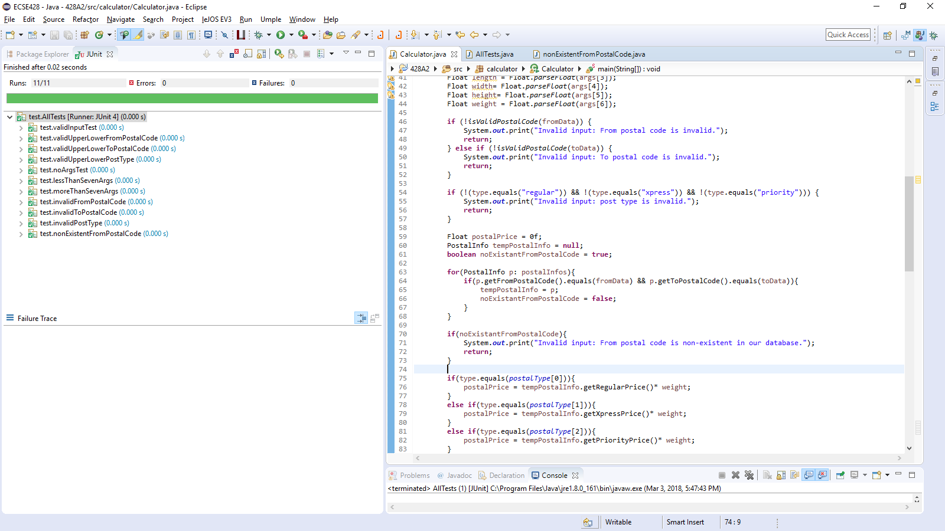

# Test x: nonExistentToPostalCode

Description:

Setup:

Expected Result:

Failing Screen Shot

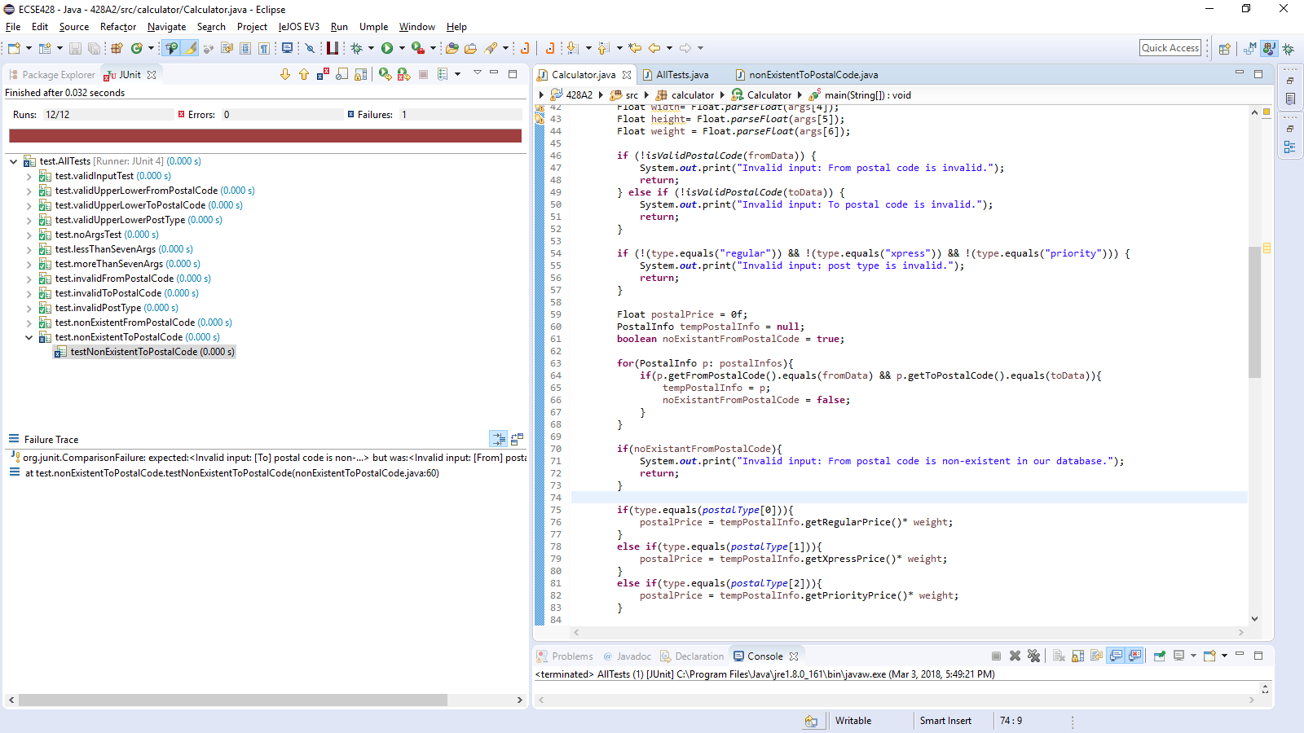

Succeeding Screen Shot

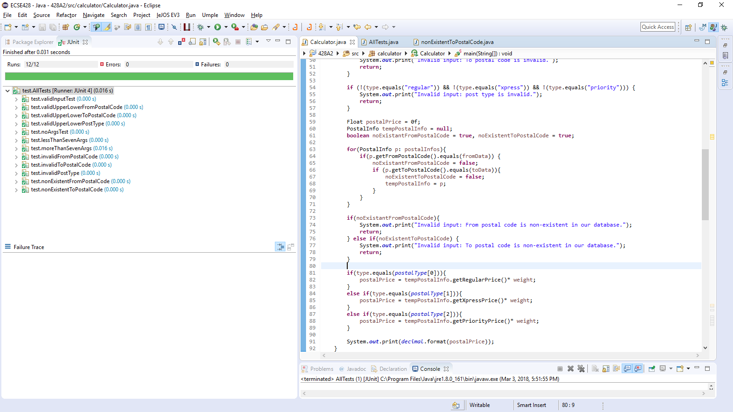

# Test x: nonMatchingPostalCodes

Description:

Setup:

Expected Result:

Failing Screen Shot

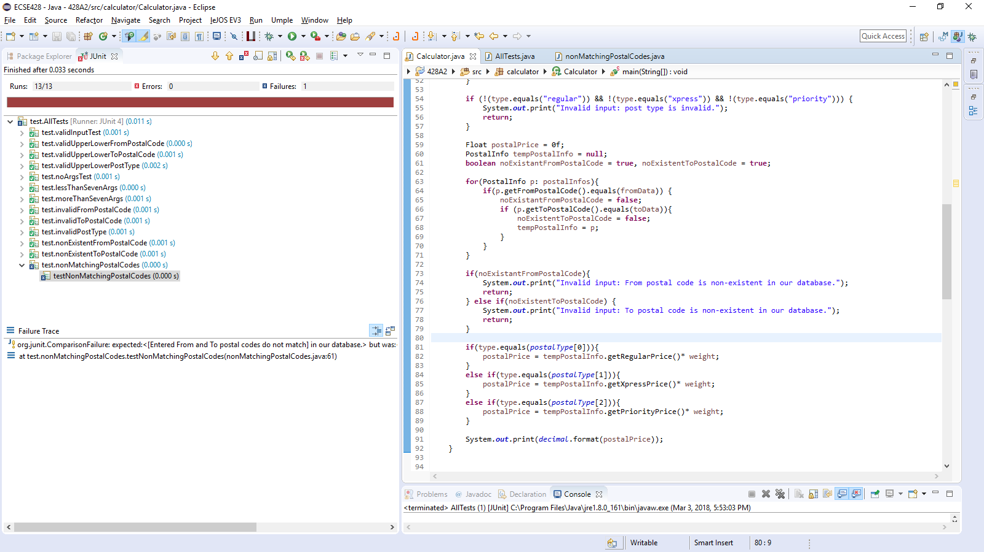

Succeeding Screen Shot

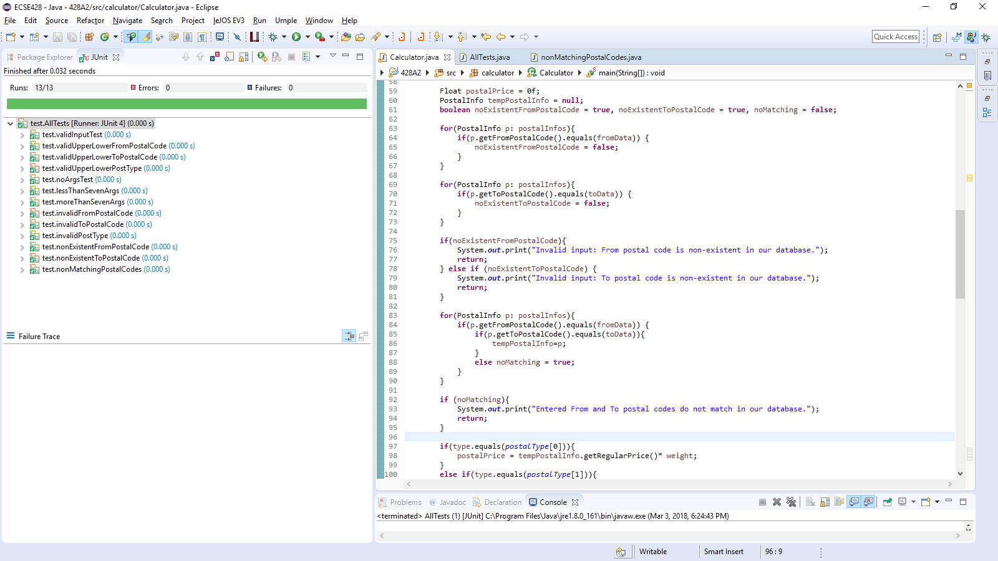

# Test x: invalidNumberInputs

Description:

Setup:

Expected Result:

Failing Screen Shot

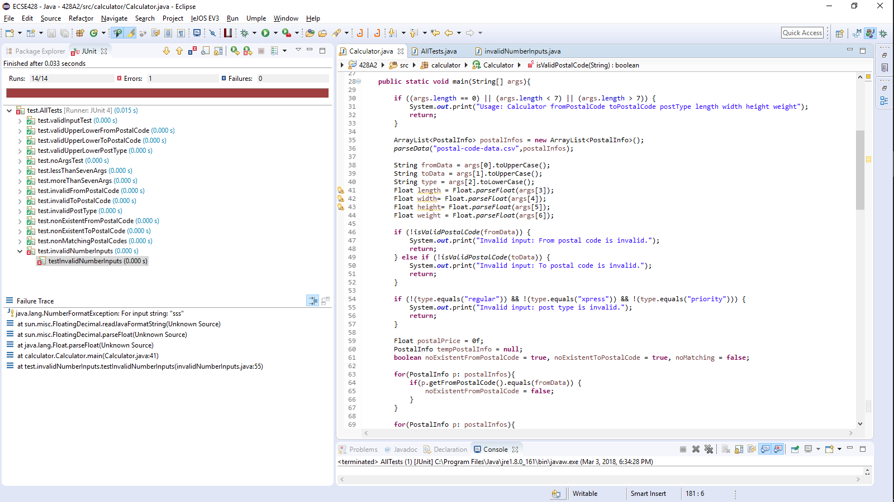

Succeeding Screen Shot

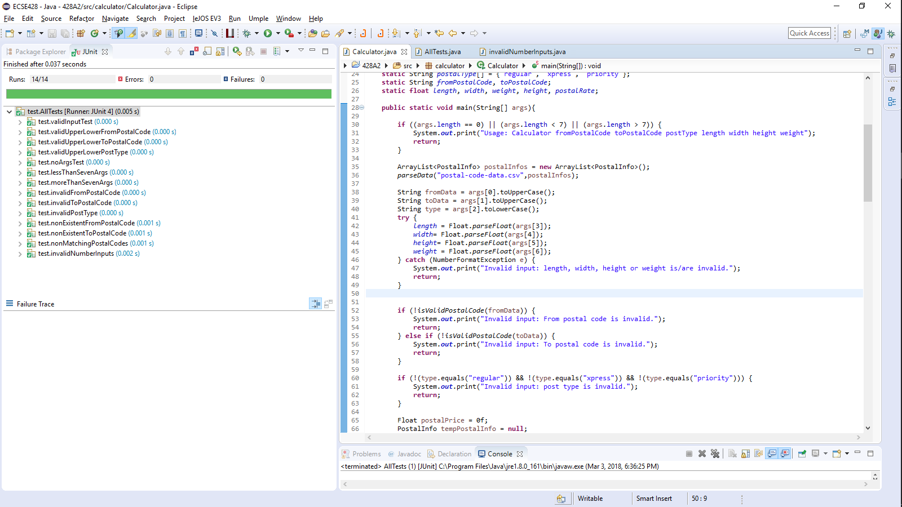

# Test x: lessOrEqualToZeroNumberInputs

Description:

Setup:

Expected Result:

Failing Screen Shot

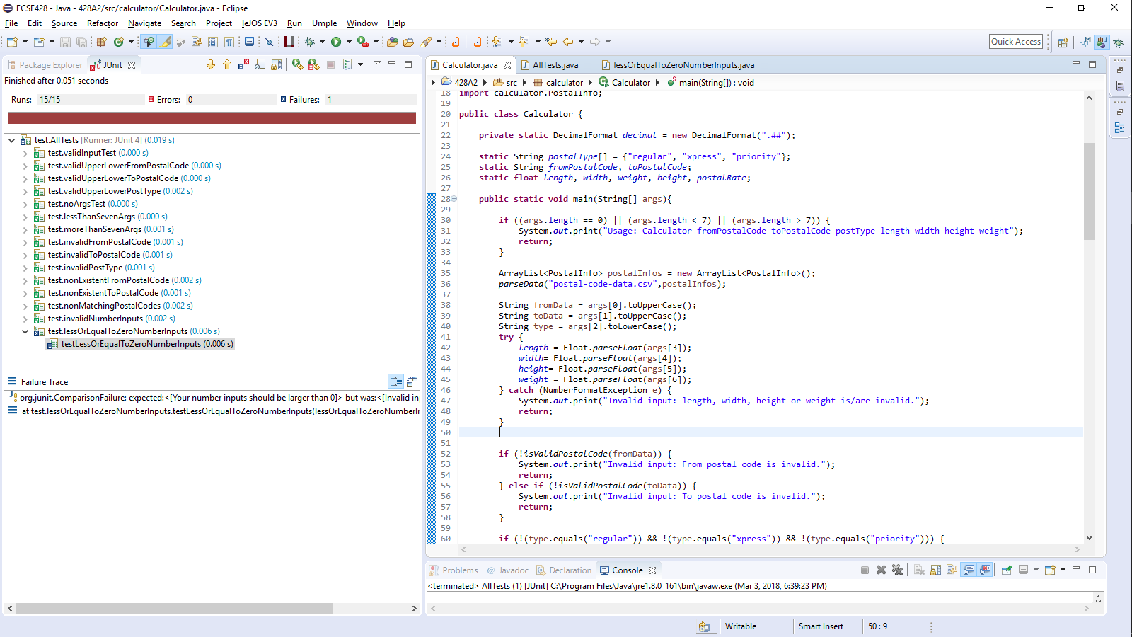

Succeeding Screen Shot

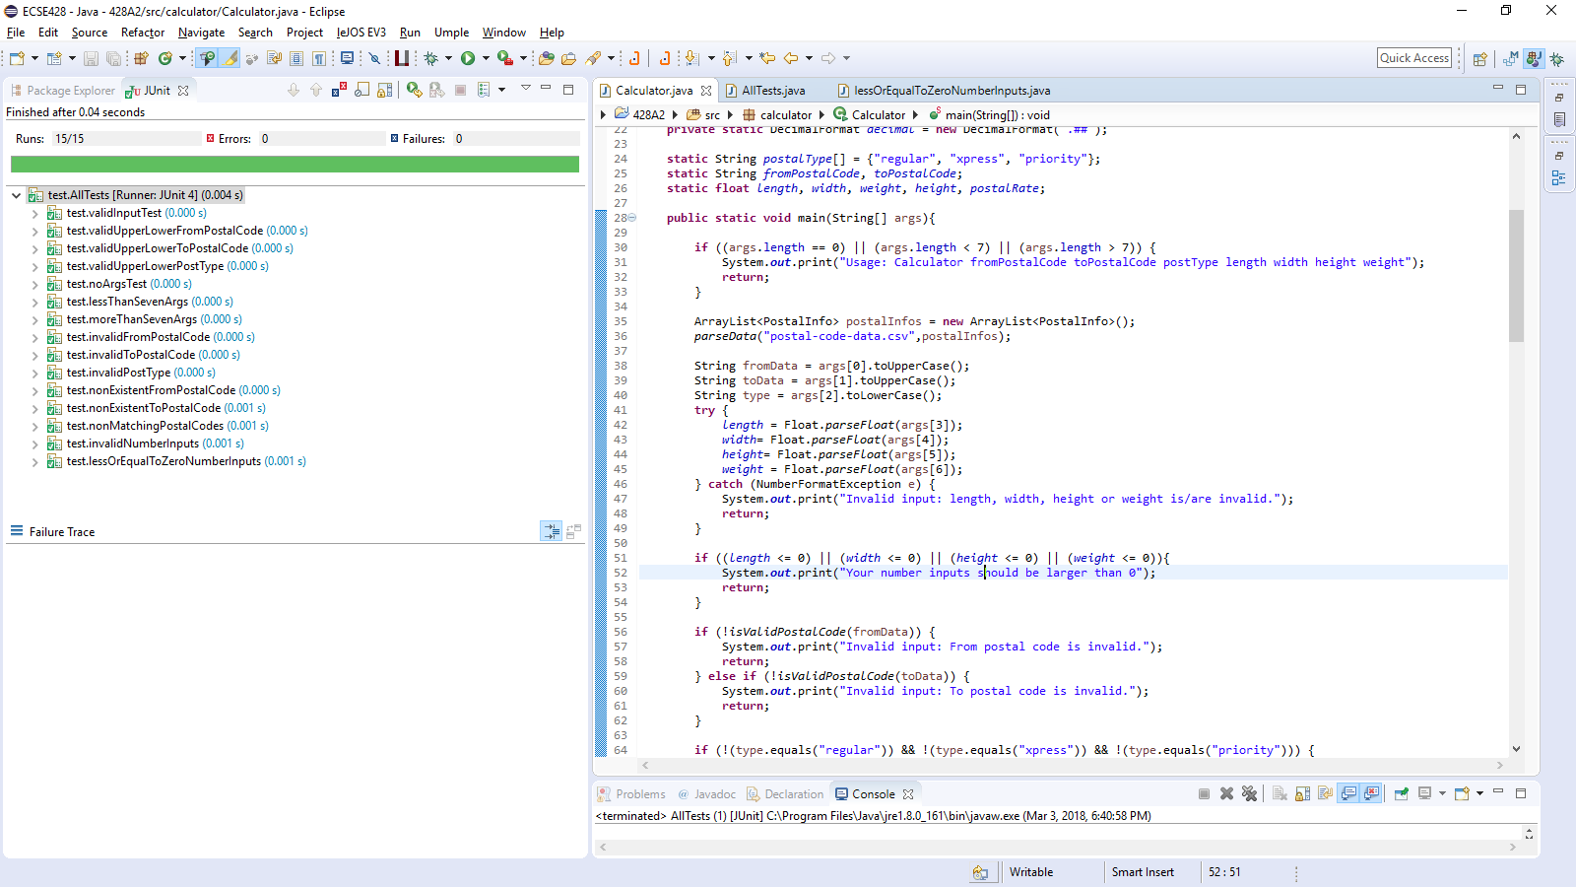

# Test x: overMaxDimensions

Description:

Setup:

Expected Result:

Failing Screen Shot

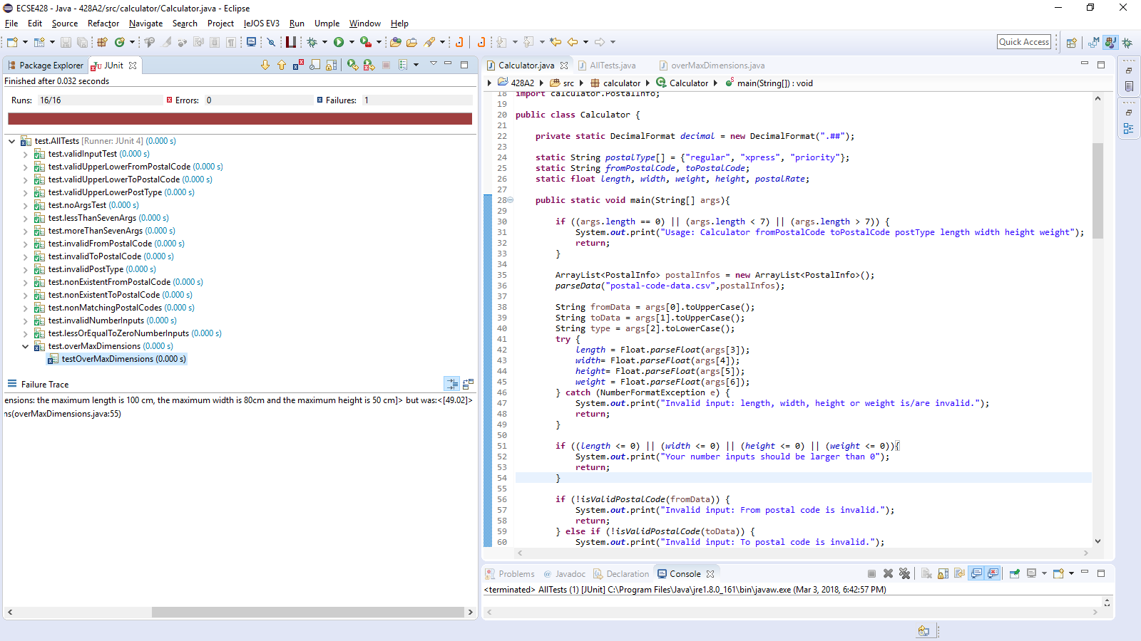

Succeeding Screen Shot

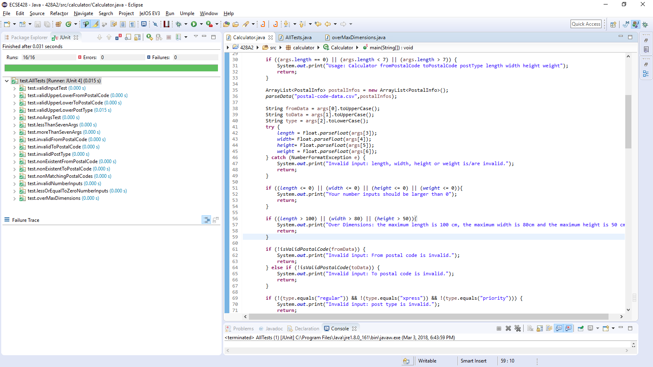

# Test x: overMaxWeight

Description:

Setup:

Expected Result:

Failing Screen Shot

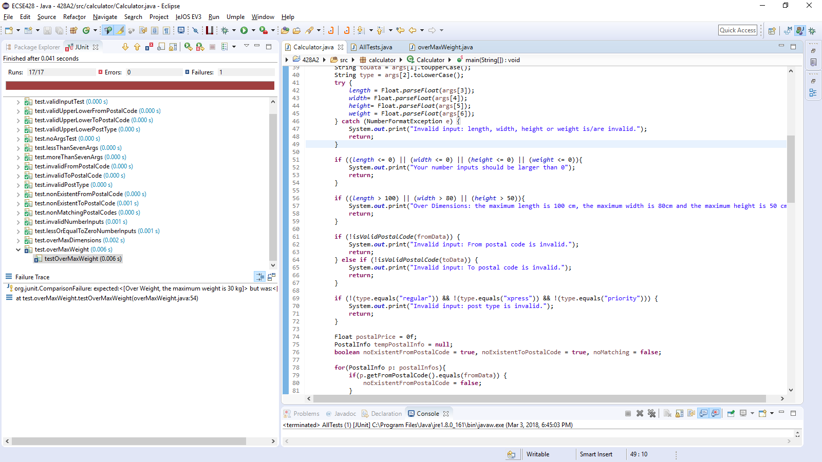

Succeeding Screen Shot

